A. The human nervous system
1. Joanna eats a toxic waste sweet, she feels a tingling in her mouth and her salivary glands release saliva. This is an example of a reflex action. Toxic waste sweets are covered in citric acid.
a. Describe the pathway of the reflex action and explain why her body reacted that way. (4)
Description (any 4)
- stimulus – sour citric acid
- receptors – chemical receptors on the tongue
- sensory neurone – impulse to the….
- relay neurone in the CNS – impulses to the…
- motor neurone – impulses to ….
- the effectors (salivary glands)
- response – saliva produced
Explanation (any 2)
- the sweet is covered in acid
- acids are sour
- acids can damage the teeth
- saliva is produced to dilute/neutralise the acid

b. Explain why reflex actions do not involve the conscious part of the brain. (2)
- So they are rapid/quick
- Less chance of damage to the body

2. Scientists investigated the effects of caffeine and alcohol on people’s reaction times.

Their results are shown in the graph.

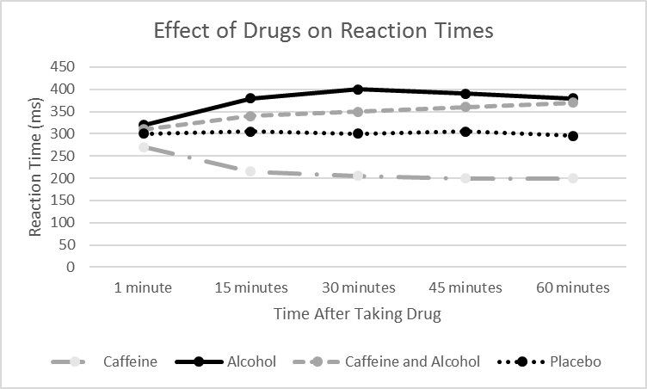

Use the data in the graph to compare the effect of the different drugs on reaction times. (4)

Any 4 from:
must compare at least two with linking points.
Caffeine only:
- decreased reaction time (RT) down to 200ms
- RT steady at 200ms from 30 to 60 mins
Alcohol only:
- increased RT up to maximum of 400ms at 30 mins
- RT falls to 60 mins but not back to normal
Alcohol and caffeine:
- RT increases but not as much as the alcohol only
- continues to rise at 60 mins
Placebo:
- no effect on RT

3. The diagram below shows the structure of the brain. (3)
- Name the structures A, B and C.
- A = cerebral cortex
- B = medulla
- C = cerebellum

- Describe and explain the function of each of the structures in part a. (3)
- Cerebral cortex – is responsible for intelligence, language, memory and consciousness
- Medulla – is responsible for involuntary coordination such as breathing, swallowing and heart rate
- Cerebellum - is responsible for voluntary coordination of the muscles

4. Extended response question:
Neuroscientists have been able to map the regions of the brain to particular functions by studying patients with brain damage.
Describe and explain the methods they use to do this. (6)
- Level 3 (5-6 marks)
Describes and explains studying brain damage, PET and CT
- Level 2 (3-4 marks)
Describes and explains either studying brain damage, PET or CT or describes ALL
- Level 1 (1-2 marks)
Makes a basic attempt to describe studying brain damage, PET or CT

Brain damage
- they can be studying patients with brain damage
- damage to different brain areas produces different behavioural and psychological effects
- by electrically stimulating different parts of the brain and seeing the changes

PET: A PET (positron emission tomography) scan uses radioactive tracer chemicals to show which parts of the brain are functioning whilst in the scanner.
It measures oxygen use and blood flow. More active parts of the brain show in red or orange colours. Green shows low activity.
A PET scan shows both the main structures of the brain and the function of the brain in real time.
PET scans are useful for studying disorders like Alzheimer’s disease where activity in parts of the brain are reduced compared to a healthy brain.

CT: A CT (computerised tomography) scan uses X-rays to produce detailed 2-d images of the brain.
A CT scan results in the body being subjected to a dose of ionising radiation that is much greater than for a simple X-ray as it takes hundreds of images.
CT scans are commonly performed and generally safe. Any increased risk of cancer usually outweighs the benefits of having the scan.
A CT scan shows the main structures of the brain. The function of the brain cannot be tested using this equipment. A CT scan will show diseased or damaged areas and this can then give a good idea of why the brain is not functioning effectively.

5. Two common defects of the eyes are myopia (short sightedness) and hyperopia (long sightedness). Both defects mean that rays of light do not focus on the retina.
Explain why people cannot see clearly with each of these defects.
You should use diagrams to explain each defect. (6)
Myopia (max 3)
- Cannot focus on objects that are far away
- It usually occurs when the eyeball is too long
- The light rays from distant objects focus in the eyeball in front of the retina
- Myopia can be corrected with concave lenses so that the light rays focus on the retina
Hyperopia (max 3)
- Cannot focus on objects that are near
- It usually occurs when the eyeball is too short
- The light rays from distant objects focus in the eyeball behind the retina
- Myopia can be corrected with convex lenses so that the light rays focus on the retina
B. Cell specialisation and cell differentiation
1. Eukaryotic cells can undergo differentiation. What does the term differentiation mean?
(2)
- How a cell changes over time (1)
- To become specialised (for a particular function) (1)

2. Explain how animal stem cells are different from plant stem cells. (3)
Any 3 from:
- Animal stem cells usually differentiate at the early stages of their life
- Stem cells in adult animals are mainly used for replacement or repair
- Plant cells differentiate throughout their life cycle
- Plant stem cells are grouped together in structures called meristems

C. Cell division
1. Describe the relationship between the cell, genes, DNA and chromosomes.
You may draw a diagram if you wish. (3)
Any three from:
- The cell contains a nucleus
- Nucleus contains chromosomes
- Chromosomes made of coiled strands of DNA
- Genes are a section of DNA that codes for a protein

2. Explain why mitosis is important for multi-cellular organisms. (3)
Any three from:
- Repairs cells
- Replace cells
- Mitosis is how new cells are formed
- Two daughter cells formed are clones of the original cell, to keep the same favourable characteristics as the parent

3. Discuss the advantages and disadvantages of the use of plant stem cells. (4)
Advantages:
- Rare species can be cloned
- Crop plants with useful features can be cloned (allow specific examples)
Disadvantages:
- Some rare species may compete with crop plants or economically useful plants
- Cloned plants may be susceptible to disease due to identical genes

4. The chart below shows public attitudes towards stem cell research using human embryos.
a. Describe the trend ‘in favour’ and ‘strongly in favour’ between 2001 and 2010. (3)
- Lowest 37% (+ or – 1) in 2002
- Highest 60% (+ or – 1) in 2005
- Since 2007 increasing

b. Calculate the percentage decrease for ‘strongly opposed’ at its highest and lowest points. (3)
highest 28% lowest 15% 28-15 = 13
$\frac{11}{28}$x 100 = 46%
c. Explain why some people may strongly oppose the use of human embryos in research. (4)
Any 2 linked points:
- Ethical reasons – destruction of the embryo
- Religious reasons – belief that life begins at fertilisation
- Risks – infections from the procedure, treatment may make disease worse

